**Data Structures Lab 05(b)**

**Course:** Data Structures (CL2001) **Semester:** Fall 2024

**Instructor: Sameer Faisal**  **T.A:** N/A

**Note:**

* Maintain discipline during the lab.
* Listen and follow the instructions as they are given.
* Just raise hand if you have any problem.
* Completing all tasks of each lab is compulsory.
* Get your lab checked at the end of the session.

**BACKTRACKING**

Backtracking is a search technique for solving complex problems by recursively exploring combinations of possible choices to arrive at a solution. It is commonly used to solve search, optimization, planning and gaming problems.

**Sample Pseudocode:**

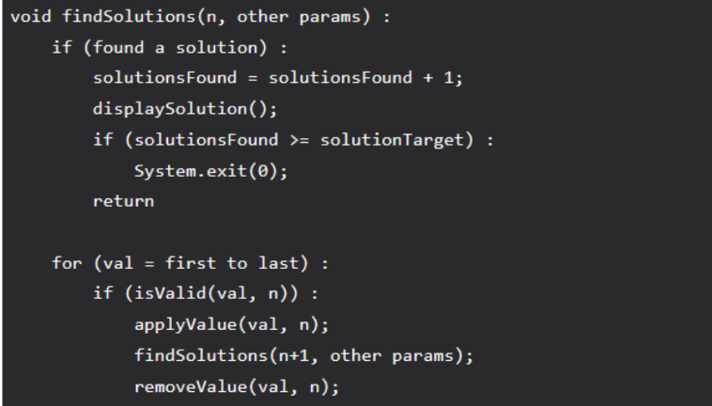

**Example 1: Rat in a Maze**

Consider a rat placed at (0, 0) in a square matrix of order N * N. It has to reach the destination at (N – 1, N – 1). Find all possible paths that the rat can take to reach from source to destination. The directions in which the rat can move are ‘U'(up), ‘D'(down), ‘L’ (left), ‘R’ (right). Value 0 at a cell in the matrix represents that it is blocked and rat cannot move to it while value 1 at a cell in the matrix represents that rat can be travel through it.

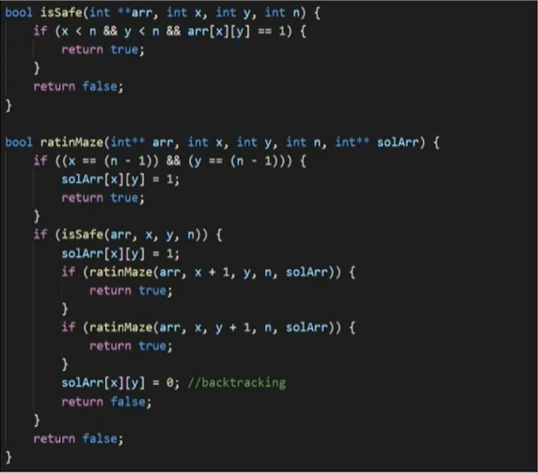

**Example 2: N-Queen Problem**

The N-Queens problem is a classic problem in computer science and combinatorial optimization. The goal is to place N queens on an N×N chessboard in such a way that no two queens threaten each other. In other words, no two queens can share the same row, column, or diagonal.

